***AI-MULTILINGUAL TRANSLATOR***

***INTRODUCTION:***

The AI Multilingual Translator serves as an advanced translation platform which handles various languages and document structures for breaking communication limitations between users. This system surpasses conventional translation tools because it combines Tesseract OCR with Google Translate API to obtain and transform written text from both PDF scans and document images and keyboard entry. This system provides real-time translation while processing documents (PDF and DOCX) through its user-centric features of text storage alongside a copy function along with download capabilities.

This project, which was created with HTML, Python (Flask), and libraries like Poppler, PyPDF2, and SQLite, guarantees accurate, smooth, and effective translations for people, companies, and researchers. The system improves accessibility and usability by fusing machine learning, natural language processing, and optical character recognition technologies, making it an effective tool for language learning, business communication, and education.

***OBJECTIVE:***

By offering a clever and effective translation system, the AI Multilingual Translator seeks to overcome language barriers. Among the main goals are::

**🔹 Multilingual Support:**

**The system can translate text into several languages**, making communication easier worldwide.

For quick and accurate translation between languages, use the Google Translate API.

🔹 **OCR-Based Text Extraction**:

Tesseract OCR is used to extract text for translation from scanned documents, PDFs, and images.

• Ensures improved recognition by operating effectively with both handwritten and printed text.

🔹 **User-Friendly Interface**:

The project guarantees a cutting-edge, simple, and intuitive user interface.

• With a few clicks, users can obtain translations of documents, photos, or text that they have uploaded.

🔹 **Document Translation (PDF & DOCX Support)**:

The system is helpful for both academic and business purposes because it can translate entire Word and PDF documents.

• Extracts text from PDFs using Poppler before translating them.

**🔹 Text Storage & Download Options**:

• The translated text is available for users to save as a PDF for later use.

• The ability to store earlier translations for convenient access.

***Scope of the Project:***

With the following features, the AI Multilingual Translator seeks to offer a complete translation solution:

✅ Supports Multiple Input Methods:  
• Users can submit scanned images for translation, upload documents (such as PDFs or DOCX), or manually type text.   
✅ OCR for Text Extraction from Images and PDFs: Tesseract OCR and Poppler are used to extract editable text from scanned documents and images.   
✅ Multilingual support and real-time translation: • It is available in more than 100 languages, making it accessible to a worldwide audience.   
✅ User-Friendly & Beautiful UI: • Offers a fluid user experience and an interactive interface with vibrant styling.   
• Drag-and-drop file uploading makes choosing documents simple.   
✅ Options for Downloading and Copying: • Users can copy translations with a single click or download translated text as PDFs.   
✅ Translation History & Storage: • Maintains a record of prior translations, making it simple for users to access earlier outcomes.   
✅ Compatibility across platforms: Works on **desktops, tablets, and mobile devices**, making it **widely accessible**

***Current System:***

* Current translation systems are less effective and user-friendly due to a number of drawbacks. Among these are: ❌ Limited Language Support: • A lot of tools only support a small number of languages, which reduces their usefulness for users from around the world.   
    
  ❌ Absence of OCR-Based Processing: • The majority of translation programs require users to manually type text because they do not support scanned documents or images.   
  ❌ Lack of Offline Capabilities: Current systems are ineffective in offline situations since they depend on an active internet connection.   
  ❌ Inaccurate Translations: Certain machine translation models produce inaccurate translations because they are unable to grasp contextual meaning.   
  ❌ Lack of Document Format Support: A lot of translation tools are less useful because they don't support scanned text extraction, PDFs, or DOCX.   
  ❌ No Text Storage or Download Functionalities: Users are unable to download translations as documents or save them for later use.   
  ❌ Simple and ugly user interface Most translation tools **lack an intuitive user interface**, making them **difficult to use** for non-technical users.

***Proposed System:***

An enhanced, feature-rich translation system with cutting-edge AI capabilities is presented by the AI Multilingual Translator.   
🚀 Text Extraction Using Advanced OCR Integration:  
• Extracts text from scanned PDFs and images using Tesseract OCR.   
• Before translating, Poppler is used to transform PDFs into text-readable formats.

🚀 AI-Powered Machine Translation: This technology provides accurate translations in real time by utilizing the Google Translate API.   
• Facilitates context-based translations for increased precision.

🚀 Support for Multiple Document Formats: • Enables users to upload and convert images (PNG, JPG, etc.) as well as PDFs and DOCX files.   
• Offers a neat and organized output for documents that have been translated.

🚀 User-friendly and interactive user interface: • Provides simple, contemporary design for effortless navigation.   
• Offers drag-and-drop uploading for an improved user experience.

🚀 Features for Downloading and Copying: • Translated text can be downloaded as a PDF for offline use.   
• A one-click copy function that allows you to use the translation quickly

***Future Scope:***

There is a lot of room for growth and expansion with the AI Multilingual Translator, including:

🔮 Speech-to-Text Translation: Future updates may support voice input for real-time translation.   
🔮 Offline Translation Mode: Using an offline translation mode eliminates the need for an internet connection.   
🔮 Better AI for Translation Accuracy: Deep learning models are used to enhance translation that is aware of context.   
🔮 Chatbot and Virtual Assistant Integration: • Including the translator in AI chatbots to provide real-time language support.   
🔮 Mobile App Development: Developing iOS and Android applications for instantaneous translation on mobile devices.   
🔮 Features for Personalized Language Learning: • Including recommendations for language learning based on user translations.   
🔮 Cloud-Based Translation Storage: Users can store their translations for convenient access from any location.   
🔮 API Integration for Companies: • Providing a translation API that can be incorporated into apps and websites.

***Software & Tools Used:***

The **AI Multilingual Translator** is built using **Python, Flask, and HTML**, with the following key libraries:

**📌 Backend Development (Python & Flask):**

* **Flask** – Manages the translation logic & document processing.
* **Google Translate API** – Provides multilingual translation.

**📌 OCR & PDF Processing:**

* **Tesseract OCR** – Extracts text from scanned images & PDFs.
* **Poppler** – Converts PDFs to text-readable format.
* **PyPDF2** – Reads and processes PDF documents.

**📌 Frontend Development:**

* **HTML, CSS, JavaScript** – Creates an interactive UI.
* **Streamlit or Flask Frontend** – For web-based implementation.

**📌 Database & Storage:**

* **SQLite** – Stores translation history for easy reference.

**📌 Additional Libraries:**

* **ReportLab** – Generates **PDF downloads** with translations.

***SOFTWARE:***

Device name: Gameon

Processor: 12th Gen Intel(R) Core(TM) i7-12700H 2.30 GHz

Installed RAM: 16.0 GB (15.6 GB usable)

Device ID: 244AA89F-3C2F-4D62-901D-3F0BFBB6F359

Product ID: 00342-43365-13608-AAOEM

System type: 64-bit operating system, x64-based processor

***Introduction***

The development of artificial intelligence (AI) has transformed many sectors, including language translation and communication. Breaking down language barriers has become essential for personal interactions, education, and business in today's globally connected world. Multilingual translation systems driven by AI have become effective instruments for promoting smooth communication between speakers of various languages. To effectively and precisely translate text, these systems make use of optical character recognition (OCR), deep learning, and natural language processing (NLP).

Manual labor is frequently used in traditional translation techniques, which can be laborious and error-prone. AI-powered multilingual translators use machine learning models that have been trained on enormous linguistic datasets to deliver accurate translations instantly. These translators are extremely flexible and applicable in a variety of fields because they integrate OCR, which allows them to extract text from images and scanned documents.

The need for multilingual translation has increased as a result of growing globalization. AI-powered translation tools are essential for businesses like healthcare, law, tourism, and e-commerce to interact with partners and clients from a variety of linguistic backgrounds. Businesses and individuals can overcome language barriers without the need for human translators when multiple languages are supported.   
An effective and user-friendly platform for translating text and documents into multiple languages is what the AI-Multilingual Translator project seeks to provide. Users can upload scanned documents or PDFs, manually enter text, and get translations right away. This system integrates advanced AI models with an intuitive user interface, enhancing usability and accessibility.

Text translation, document translation, OCR-based text extraction from images, and the ability to download or copy the translated text are among the project's primary features. The system guarantees high accuracy, speed, and convenience in multilingual communication by fusing web technologies with artificial intelligence.   
Multilingual translators' comprehension of cultural quirks and context will advance as AI develops. One step toward a time when language won't be an obstacle to international communication is the AI-Multilingual Translator project.

***Motivation***

Effective multilingual communication is more crucial than ever in the fast-paced digital world of today. To communicate with a variety of audiences, many sectors—including business, healthcare, education, and research—need effective translation tools. AI-powered multilingual translation systems have emerged as a result of the high cost and frequent inability of traditional translation services to satisfy real-time demands.   
The need for an accessible and reasonably priced translation service that serves both individuals and businesses is a primary driving force behind this project. A multilingual translator is now a need rather than a luxury due to the rapid expansion of globalization and the frequent interaction of people from various linguistic backgrounds. Real-time translations provided by an AI-based translation system guarantee more seamless and delay-free communication.

The limitations of human translators are another motivating factor for this project. Although human translation is frequently accurate, it is impractical and time-consuming for urgent or large-scale tasks. On the other hand, AI-powered translators are extremely effective for companies, students, and researchers who regularly work with foreign languages because they can process large volumes of text instantly.   
Additionally, a large number of historical texts and digital documents are in languages that may not be widely spoken. Language barriers won't cause important information to be lost thanks to the ability to extract text from images and translate them into multiple languages. Our AI-Multilingual Translator offers a complete solution for managing different document formats by incorporating OCR technology.  
Another field where language translation is essential is education. Numerous pupils

Lastly, a major motivator is accessibility for people with disabilities and non-native speakers. An AI-powered translator offers an inclusive solution that enables people who struggle to read or comprehend foreign languages to have conversations, read documents, and comprehend content in their preferred language with ease.

***Scope of Project***

1. Real-time Text Translation: Using AI-based translation models, the project enables users to manually enter text and have it translated into multiple languages instantly. The AI-driven system guarantees that translations are precise, pertinent to the context, and produced in a matter of seconds. AI translation models employ neural networks to comprehend the subtleties of various languages, as opposed to conventional dictionary-based translations, guaranteeing improved comprehension. Professionals, students, and tourists who require accurate and fast translations will find this feature especially helpful.   
  
2. Document Translation: Scannable documents, such as PDFs and pictures, can be uploaded by users for text extraction and translation. Because it can handle a variety of document formats, this feature gives the system great versatility. Users are guaranteed a well-formatted output because the translation process preserves the original document's structure.

3. Because it can handle a variety of document formats, this feature greatly expands the system's versatility. Users are guaranteed a well-formatted output because the translation process preserves the original document's structure. Businesses that deal with international contracts, research papers, and legal documents that need to be translated accurately without losing context will especially benefit from this.   
4. OCR, or optical character recognition The system can extract text from scanned documents and images thanks to the integration of OCR technology. This enables users to translate non-digital materials like historical manuscripts, printed books, and handwritten notes. These texts are transformed into machine-readable formats by OCR technology, and AI-based translation models are then used to process them. In academic and archival research, where maintaining accuracy is crucial, this feature is especially helpful.

5. User-friendly Interface: The project prioritizes an interface that is clear, simple, and easy to use. The features are accessible and usable by users with varying technical skill levels without the need for intensive training. Clear instructions, easy-to-use file upload buttons, and a smooth text translation process are all features of the design. An organized interface improves user experience and facilitates efficient and seamless translation tasks.   
  
  
6. Multilingual Support: The AI-Multilingual Translator is helpful for users worldwide in a variety of industries because it supports a large number of languages. The system offers precise and contextual translations, regardless of whether users require translations for lesser-known languages or for widely used languages like English, Spanish, and French. International students, researchers using multilingual data sources, and companies entering new markets will all benefit from this feature.

7. Download and Copy Features: With just one click, users can copy or download translated text as a document. When working with lengthy texts or official documents, this guarantees efficiency. For example, students can readily extract important points from foreign research papers, and business professionals can quickly translate and save contracts. The platform's overall usability is improved by the capacity to store and distribute translated content.   
8. Integration with Web Technologies: HTML is used for frontend development and Python (Flask) for backend processing in this project. Flask facilitates seamless request handling and API interactions, guaranteeing prompt responses. The platform can be accessed on a variety of devices, such as desktops, tablets, and smartphones, thanks to the utilization of web technologies. The system provides a smooth and responsive experience by combining these technologies.

***Environment Used***

***[VS Code]***

***Introduction to VS Code***

Microsoft created Visual Studio Code (VS Code), a sophisticated, portable, open-source code editor. Because of its remarkable speed, efficiency, and feature-rich environment, it has become extremely popular among developers. Because it is a cross-platform editor, a wide variety of users can use it because it supports Windows, macOS, and Linux. In contrast to conventional IDEs, Visual Studio Code offers both novice and seasoned developers the ideal mix of robust features and ease of use.

Python, HTML, JavaScript, and other programming languages are all seamlessly supported by Visual Studio Code, which is one of the main reasons it was chosen for this project. Integrated debugging tools, intelligent code completion, version control integration, and a vast marketplace with a plethora of extensions that expand its functionality are all included with the editor.

***Benefits of VS Code***

1. Lightweight and Fast – Unlike heavy IDEs that consume large amounts of system resources, VS Code is designed to be lightweight. It launches quickly and runs smoothly even on low-end systems, ensuring optimal performance during software development.

2. Integrated Debugging – One of the standout features of VS Code is its built-in debugging support. It allows developers to set breakpoints, inspect variables, and execute code step-by-step, making it easier to identify and fix errors without requiring external debugging tools.

3. Extensive Extensions Marketplace – VS Code offers an extensive library of extensions that enhance its functionality. Developers can install plugins for AI tools, linters, additional language support, and framework integrations, enabling a highly customizable development experience.

4. Integrated Git Support Software development requires version control, which VS Code makes easier with its integrated Git integration. The workflow is streamlined by allowing developers to manage branches, push and pull from repositories, and commit changes all within the editor.   
  
5. Customizable Themes and UI: Visual Studio Code offers a wide range of customization choices that let developers make their workspace uniquely their own. The editor's layout, key bindings, and theme can all be changed by users to increase comfort and productivity.

6. Multi-language Support: Python, JavaScript, C++, HTML, and many other programming languages are supported by Visual Studio Code. Because of its adaptability, it can be used for a wide range of tasks, such as machine learning, web development, and artificial intelligence.

***Libraries Used***

To implement essential features like text translation, OCR, document handling, and web framework integration, the AI-Multilingual Translator project makes use of a number of Python libraries. A thorough description of each library used in the project can be found below:   
  
1. Flask: The application's backend is constructed using Flask, a lightweight web framework. It facilitates the rendering of web pages using HTML templates and makes API integration simple. The smooth interaction between the frontend and backend components is made possible by Flask.  
• It enables developers to design routes (/translate, /upload, etc.) for the translator's various features.   
  
• Offers an integrated debugger and development server for testing and debugging web applications.   
• Supports Jinja2 templating, which enables dynamic HTML page rendering in response to user input.   
• Facilitates the integration of APIs to link to services such as

2. Googletrans: This library facilitates automatic multilingual text translation by acting as an interface for the Google Translate API. It is essential for processing user input and providing real-time translated results.   
• Instantly returns the translated output and shows it in the user interface after receiving user input (text or text extracted from OCR) and translating it into the chosen language.   
• Supports a variety of languages, giving users the option to select the output language they want.   
  
3. Pytesseract: This Python wrapper for Tesseract OCR is used to extract text from scanned documents and images. It enables the system to translate characters from various languages into editable text.   
• Transforms text based on images into editable digital text.   
It is appropriate for a multilingual translator because it supports multiple languages and can process

4. pdf2image: This library allows text extraction from scanned or digital PDFs by converting PDF documents into images. Managing translations based on documents requires it.   
• Scanned text that cannot be directly extracted is frequently found in PDFs.  
• For OCR processing, every PDF page is converted into an image format (PNG, JPG, etc.).   
• Supports both scanned and text-based PDFs by collaborating with PyMuPDF.   
  
5. OS: Python's os module offers features for interacting with the operating system, including managing file directories, reading environment variables, and handling file paths. It facilitates file handling for document processing and uploads in this project.Primary Python file: app.py   
• Oversees the directories and file paths used to store uploaded documents.   
• Reads and writes files while translating and extracting text.   
• Assists in managing documents (such as retrieving

**6.PIL (Python Image Library)** - The Python Imaging Library, also known as PIL, is a necessary component for image processing tasks in SanskritScribe. It offers crucial functionality for image manipulation and preprocessing prior to OCR tasks. Its extensive feature set guarantees image processing quality and compatibility, allowing precise Sanskrit text extraction from uploaded images. SanskritScribe's capabilities are improved by utilizing PIL, which lets users upload and process images with Sanskrit text with ease. This encourages a greater comprehension and admiration of the language and its cultural legacy by enabling users to interact with Sanskrit literature in an effective manner.

***Main Python File: app.py***

The core of the AI-Multilingual Translator project is the app.py file. It includes the essential logic for managing the backend operations with Flask, processing translations, and handling user inputs. Several functions, including document handling, text input processing, and OCR-based text extraction, are routed by this file.   
The web-based interface is powered by the Flask framework, which enables smooth user interaction with the application. The frontend and backend components work together seamlessly thanks to the app.py script, which also handles API calls and retrieves translated text. The system can efficiently process and translate text thanks to the integration of multiple Python libraries within app.py.

***Libraries Used in app.py***

1. **Flask** – Used for backend development and handling web requests.
2. **Googletrans** – Manages language translation functions.
3. **Pytesseract** – Extracts text from images for OCR-based translation.
4. **pdf2image & PyMuPDF** – Extracts text from PDFs and converts them for translation.
5. **OS** – Used for file handling and system interactions.
6. PIL (Python Library Image): PIL preprocesses images for OCR tasks in SanskritScribe, ensuring accuracy.

***API Used in This Project***

1. Google Translate API (GoogleTrans Library, unofficial version)   
What is the Google Translate API?  
Google offers a cloud-based service called the Google Translate API that enables real-time text translation between multiple languages for applications. It provides incredibly accurate translations by utilizing neural networks and sophisticated machine learning.   
  
This project makes use of googletrans, an unofficial API wrapper for Google Translate, because the official Google Cloud Translation API is a paid service that requires an API key. It supports more than 100 languages and provides free translation.

**Why Google Translate API is Used?**

* **Automatic Language Detection** – Detects the input language before translation.
* **Supports Over 100 Languages** – Provides wide multilingual support.
* **Fast and Efficient** – Allows real-time translation for text and documents.
* **Easy to Integrate** – Can be used with just a few lines of Python code.
* **No API Key Required** – Unlike the official Google Cloud API, googletrans can be used freely without authentication.

**How It Works in This Project?**

1. The **Flask backend** receives text input from the user.
2. The **Google Translate API (via googletrans)** detects the input language.
3. The **translated text** is returned and displayed on the web interface.

**2. OCR APIs (Tesseract OCR)**

**What is Tesseract OCR API?**

The **Tesseract OCR (Optical Character Recognition) engine** is an open-source tool developed by Google that extracts text from images and scanned documents. The pytesseract library is used in this project as a Python wrapper for Tesseract OCR.

**Why Tesseract OCR API is Used?**

* Extracts text from **scanned images and PDFs**.
* Supports **multiple languages**, making it ideal for a multilingual translator.
* Works with **OpenCV** to enhance image clarity before text extraction.

**How It Works in This Project?**

1. Users **upload an image or scanned PDF**.
2. The **Tesseract OCR API** extracts text from the image.
3. The extracted text is **sent to the Google Translate API** for translation.

***CODING PART***

**MAIN FILE – AI-MULTILINGUA TRANSLATOR**

To open the source file, we will first open the visual studio code .

**OPENING VISUAL STUDIO CODE :**

**STEP 1 :**

In your windows search bar , type visual studio code

**STEP 2 :**

Click on the open and it will open the visual studio code.

The interface after opening looks like this –

**STEP 3:**

Opening the project directory which is –

"C:\Users\amaan\OneDrive\Desktop\ai_multilingual_translator" in visual studio code by selecting open folder and then select the folder .

It will be seen like this :

STEP 4: In this folder, the subdirectories and files looks like this:

Let us begin with code explanation:

***PYTHON***

The high-level, interpreted Python programming language is renowned for its ease of use, readability, and adaptability. Python was developed by Guido van Rossum and initially made available in 1991. Its simple syntax and emphasis on code readability make it a great option for both novice and seasoned developers. Procedural, object-oriented, and functional programming are among the various programming paradigms that it supports. Python can be used in a wide range of applications, from data analysis and web development to automation, scientific computing, and artificial intelligence, thanks to its robust ecosystem of third-party packages and large standard library. Its popularity as one of the most popular programming languages worldwide is further bolstered by its cross-platform compatibility and vibrant community.



In order to construct the backend of the AI Multilingual Translator, this line of code imports necessary Flask modules. The main framework for building the web application is Flask. The front-end interface's HTML templates are rendered using render_template. request manages HTTP requests, including those involving user input for translation. Downloading translated documents is made possible by send_file, and handling API interactions is made simpler by using jsonify to return JSON responses. For effective user request handling, translation processing, and response delivery, these imports are essential.



The os module, which offers functions to communicate with the operating system, is imported by this line. It probably handles file operations like saving, retrieving, and removing translated documents or images in the AI Multilingual Translator project. It makes possible features like file path management, directory creation, and operating system compatibility. This module is necessary for effectively managing uploaded documents and arranging translated files.



A Python wrapper for Google's Tesseract-OCR engine, the pytesseract module is imported with this line. Pytesseract is utilized in the AI Multilingual Translator project to enable Optical Character Recognition (OCR) by extracting text from scanned documents and images. When translating text that is embedded in pictures or PDFs that contain scanned text, this is crucial. The program can identify and transform printed or handwritten text into machine-readable text for additional processing and translation by utilizing Pytesseract.



In order to handle and process images, this line imports the Image module from the Python Imaging Library (PIL) package. Before applying OCR using Pytesseract, images must be opened, read, and converted in the AI Multilingual Translator project. It enables the program to load image files (like PNG, JPG, or BMP), perform preprocessing on them (like resizing or grayscale conversion), and then extract text for translation. This improves the translator's functionality and guarantees higher text recognition accuracy.



To turn PDF pages into images, this line imports convert_from_path from the pdf2image library. This feature enables the AI Multilingual Translator project to process scanned or text-based PDF documents by turning each page into an image.



In order to work with Microsoft Word documents (.docx files), this line imports the Document class from the docx module (also called python-docx). This enables the AI Multilingual Translator project to read, modify, and extract text for translation from Word documents. It increases the system's adaptability to handle different document formats by allowing users to upload.docx files, extract their contents, and translate the text.



In order to use Google Translate's API to translate text between multiple languages, this line imports the Translator class from the googletrans library. This module is essential to the AI Multilingual Translator project because it converts text that has been extracted (from documents, photos, or user input) into various languages. Using GoogleTrans, the application

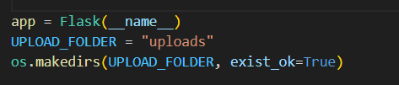

This code creates a directory to hold uploaded files and initializes the Flask application.   
By creating an instance of the Flask application, app = Flask(__name__) enables it to manage web requests and responses. Finding templates, static files, and configurations is made easier by Flask knowing the module name thanks to the __name__ variable.  
• UPLOAD_FOLDER = "uploads": This specifies a directory called "uploads" where uploaded files (like pictures, PDFs, or DOCX files) will be kept while they are processed.   
  
• os.makedirs(UPLOAD_FOLDER, exist_ok=True): If the "uploads" folder doesn't already exist, it is created. If the folder already exists, the exist_ok=True argument avoids errors and guarantees error-free, seamless operation.

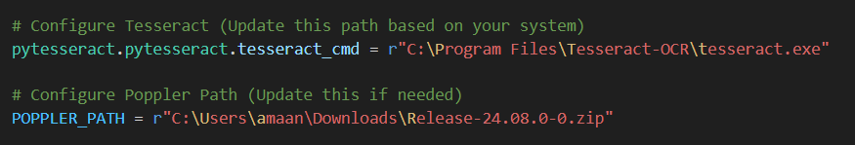

Tesseract OCR and Poppler, two crucial programs for text extraction from photos and PDFs, are configured by this code.   
• To configure Tesseract, use pytesseract.pytesseract.tesseract_cmd = r"C:\Program Files\Tesseract-OCR\tesseract.exe."   
  
The pytesseract library can access the OCR engine thanks to this line, which sets the path to the Tesseract executable. In order to process scanned documents or image-based text for the AI Multilingual Translator project, Tesseract—an optical character recognition (OCR) tool that extracts text from images—is essential. By placing r before the string, backslashes (\) are avoided and the path is handled as a raw string.   
  
• Setting up Poppler: POPPLER_PATH = r"C:\Users\amaan\Downloads\"Release-24.08.0-0.zip"   
The path to Poppler, a library for turning PDFs into images, is defined by this line. Poppler is used by the pdf2image library to extract images from PDF pages, which can subsequently be processed. If Poppler is not correctly configured, the system may fail to process PDF files.

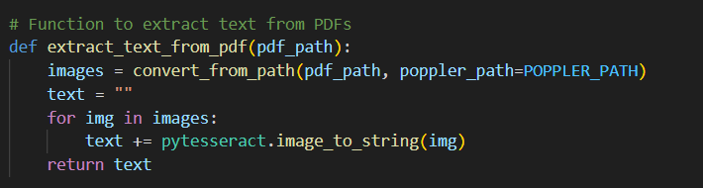

This Python function, extract_text_from_pdf(pdf_path), is designed to extract text from a PDF file using **Poppler and Tesseract OCR**.

1. **Convert PDF to Images**:

images = convert_from_path(pdf_path, poppler_path=POPPLER_PATH)

The function uses convert_from_path() from the pdf2image library to convert each page of the given pdf_path into an image. The poppler_path=POPPLER_PATH ensures that the Poppler library is used for this conversion. Since PDFs are not directly readable as text, converting them into images allows us to apply OCR for text extraction.

1. **Extract Text Using Tesseract**:

text = ""

for img in images:

text += pytesseract.image_to_string(img)

This loop iterates over all the images generated from the PDF pages. The pytesseract.image_to_string(img) function applies Tesseract OCR to each image, extracting any readable text. The extracted text from each page is then appended to the text variable. Finally, the function returns the complete extracted text.

The purpose of the Python function extract_text_from_pdf(pdf_path) is to use Poppler and Tesseract OCR to extract text from a PDF file.   
1. Use images = convert_from_path(pdf_path, poppler_path=POPPLER_PATH) to convert PDF to images.   
  
Each page of the supplied pdf_path is converted into an image by the function using convert_from_path() from the pdf2image library. The Poppler library is used for this conversion thanks to the poppler_path=POPPLER_PATH setting. We can use OCR for text extraction by turning PDFs into images because they are not directly readable as text.   
  
2. Use Tesseract to Extract Text:   
text = "" for images' img:   
text += pytesseract.image_to_string(img)   
Every image created from the PDF pages is iterated over in this loop. Tesseract OCR is applied to every image by the pytesseract.image_to_string(img) function, which extracts any readable text from the image. This extracted text is then returned as output.

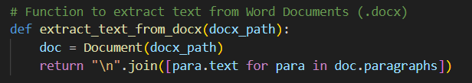Using the python-docx library, the Python function extract_text_from_docx(docx_path) retrieves text from a Word document in the.docx format.   
1. Document Loading:  
Doc = Document(docx_path)   
  
The function loads the Word document using Document(), which is a component of the Python-docx library, and accepts a file path (docx_path) as input. This enables the application to read the.docx file's contents.   
2. Extracting and Formatting Text: return " ".join([para.text for para in doc.paragraphs])   
The function extracts the text content from each paragraph in the document (doc.paragraphs) by iterating through them all. The document's structure is maintained by the "\n".join(...), which makes sure that each paragraph's text is separated by a newline (\n). Lastly, the extracted text is returned by the function.

Using the Google Translate API and the googletrans library, the Python function translate_text(text, target_lang) converts a given text into a specified target language.   
1. Setting up the Translator: translater = Translator()   
  
In order to access Google's translation service, the function generates an instance of the Translator class from googletrans.   
  
2. Translating: translated = translator.translate(text, dest=target_lang)   
Using the dest parameter, the translate() method converts the input text into the language designated by target_lang.   
  
3. Getting the Translated Text Back: return translated.text   
The translated text is taken out of the translated object and returned by the function.   
This feature is helpful when creating multilingual applications that require dynamic text conversion between languages, like chatbots, AI-powered translators, or document translation systems.

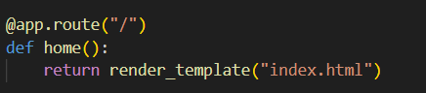

A web application's home page is defined by this Flask route.   
1. Route Definition (@app.route("/")):  
o This function will handle requests to the root URL ("/"), as specified by the @app.route("/") decorator.   
  
o This function is carried out when a user accesses the web application's base URL.   
2. Home Function (home()):   
o The rendered index.html template is returned by the home() function, a straightforward view function.   
An HTML file from the templates folder is dynamically loaded and returned by the Flask function render_template("index.html").

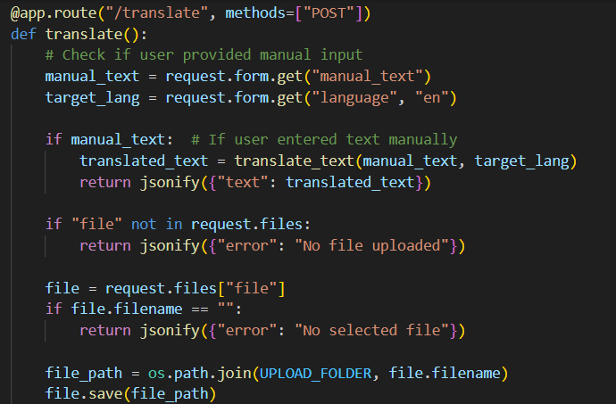

Text translation requests are handled by this Flask route (/translate) using a POST protocol. Both manually entered text and uploaded files are processed for translation.   
1. Text handling by hand:  
o The function uses request.form.get() to retrieve user input from an HTML form.   
  
o It determines whether the user manually entered the text (manual_text).   
o To translate the input into the target language (target_lang, which by default is English), it invokes translate_text() if it is present.   
o Next, jsonify() is used to return the translated text as a JSON response.   
2. File Handling: o It determines whether a file has been uploaded if no manual text is supplied.   
o It returns an error message ("No file uploaded") if "file" is not present in request.files.   
o If the file exists but is nameless, it returns

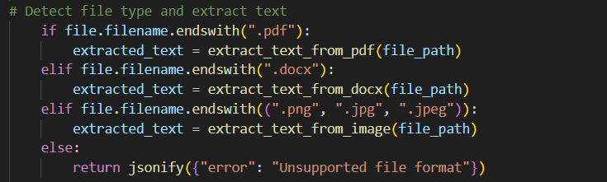 The task of identifying the file type and extracting text appropriately falls to this snippet of code. It uses file.filename.endswith() to verify the uploaded file's extension before processing it with the relevant extraction function.   
1. PDF Files (.pdf): If the file is a PDF, it calls extract_text_from_pdf(file_path), which probably parses embedded text or extracts text from PDF images using optical character recognition (OCR).  
2. Word Documents (.docx): This function retrieves text from paragraphs in a Word document by calling extract_text_from_docx(file_path) if the file is a Word document.   
  
3. Image Files (.png,.jpg,.jpeg): If the file is an image, it calls extract_text_from_image(file_path), which probably makes use of OCR (pytesseract) to identify and extract text from the image.   
4. Unsupported File Formats: A JSON response is returned if the 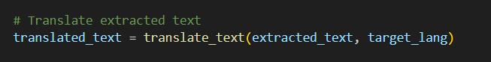file format is not recognized.

The extracted text must be translated into the target language by this snippet of code. The function translate_text(extracted_text, target_lang) is invoked, where target_lang indicates the language into which the text is to be translated and extracted_text contains the text taken from a document or image.   
To process the extracted text and return the translated output, the function most likely makes use of a translation API (like Google Translate). In order to ensure that users can translate text from various file formats (such as Word documents, PDFs, or images) into the language of their choice, this step is essential to multilingual document processing.

This bit of code is in charge of returning a response in JSON format and saving the translated text to a file. By joining the UPLOAD_FOLDER directory with the filename "translated.txt," the variable translated_file_path specifies the path where the translated text will be stored. The with open(...) statement ensures that various character sets are handled correctly by opening the file in write mode ("w") with UTF-8 encoding. This file is then updated with the translated text.   
Following file saving, the function uses jsonify() to return a JSON response that contains the translated text and a "download_url" key that points to the "/download" endpoint. This enables users to download and access the translated file at a later time. Applications where users need to access translated documents in an organized manner can benefit from this implementation.

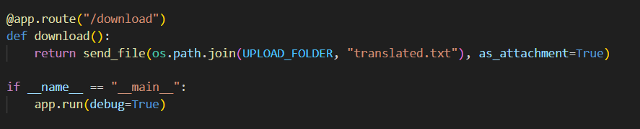

The translated text file can be downloaded by users thanks to the Flask route ("/download") defined by this code. The "translated.txt" file is retrieved from the UPLOAD_FOLDER directory and sent as an attachment by the download() function using send_file(). The file will be downloaded rather than shown in the browser thanks to the as_attachment=True option.   
The if __name__ == "__main__": block at the bottom makes sure that the Flask application launches when the script is run directly. The Flask web server is started in debug mode by the app.run(debug=True) statement, which enables automatic reloading and real-time error tracking while development is underway. Before deploying the application, this configuration is essential for testing and improving its functionality.

***HTML [HyperText Markup Language] & CSS***

Language barriers are a major communication challenge in today's globalized world. In order to get around this, we created an AI-Powered Multilingual Translator, a web application that lets users effectively translate documents and text between several languages. This project is a strong and intuitive tool that combines HTML, CSS, and JavaScript with backend support for translation services.   
Technology Stack • HTML: Provides input fields for text and file translation and organizes the webpage.   
  
• CSS: Gives the user interface a more contemporary and responsive look with features like interactive buttons, gradient backgrounds, and elegantly styled text sections.   
• JavaScript: Manages user interactions, implements the translation logic, and connects to the backend for text processing.   
• Flask/Python backend: handles user input, makes use of OCR for scanned documents, and establishes a connection with the Google Translate API for

***Key Features***

✅ Manual Text Translation: This feature allows users to enter text and choose the language they want it translated instantly.

✅ File Upload & Translation: This feature allows users to translate documents, including scanned images (if they have OCR enabled).  
✅ Translations can be downloaded or copied for later use by users.   
  
✅ User-Friendly Interface: Featuring a smooth user interface, eye-catching colors, and an intuitive layout.   
This project aims to provide a fast, reliable, and accessible translation tool for individuals, businesses, and educational institutions, bridging the language gap efficiently.

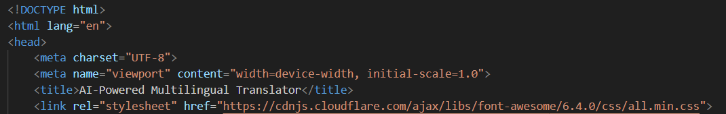

The head section of a webpage for an AI-powered multilingual translator is represented by this HTML code. The document conforms to the HTML5 standard, as indicated by the declaration. The document's language is specified as English by the tag.   
✅ inside the section guarantees correct text encoding, enabling support for multiple languages and special characters.   
  
✅ makes the page responsive, meaning it adjusts to various screen sizes.   
✅ modifies the title that appears on the tab of the browser.   
✅ imports Font Awesome, a popular library for icons, which can be used to enhance the UI with visual elements like buttons and navigation icons

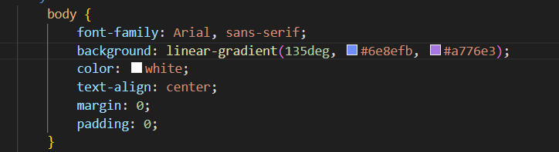

This CSS code specifies how the webpage's should look. It ensures that the text looks clear and readable by setting the font family to Arial, sans-serif. A visually appealing effect is produced by setting the background to a linear gradient that transitions from #6e8efb, a blue shade, to #a776e3, a purple shade, at an angle of 135 degrees.

Furthermore, the text is readable against the gradient background because the color is set to white (color: white;). The alignment of the text content within the body is guaranteed by the text-align: center;. By removing any default spacing, the margin: 0; and padding: 0; make sure that the background and content fill the entire screen without any gaps. The UI is improved by this styling, which makes it more contemporary, aesthetically pleasing, and intuitive.

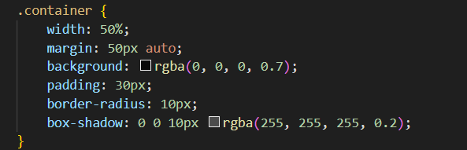

This snippet of CSS (Cascading Style Sheets) code styles a container element.   
• The width of the.container class is set to 50%, which means it will occupy half of the width of the parent element or screen.  
• margin: 50px auto; adds a 50px margin at the top and bottom and centers the container horizontally.   
  
• Background: rgba(0, 0, 0, 0.7); applies a black background that is semi-transparent (the final value, 0.7, indicates 70% opacity).   
• padding: 30px; this adds 30 pixels of extra room inside the container.   
• border-radius: 10px; creates a smooth appearance by rounding the container's corners.   
• box-shadow: 0 0 10px rgba(255, 255, 255, 0.2); this creates a gentle white shadow that gives the container a faint glow.

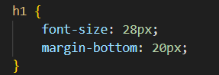

All <h1>**(heading 1) elements on a webpage are styled by this CSS (Cascading Style Sheets) rule.   
• font-size: 28px; makes the**

**heading bigger and more noticeable by setting the text size to 28 pixels.  
• margin-bottom: 20px; this adds 20 pixels of space beneath the heading to make sure that it and the following element on the page are somewhat apart.**

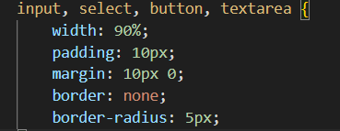

This **CSS code** is used to style multiple HTML form elements: <input>, <select>, <button>, and <textarea>. It ensures a consistent design across these elements by applying common styles.

* width: 90%; → Makes the elements take up 90% of the available width.
* padding: 10px; → Adds 10 pixels of space inside the elements for better readability.
* margin: 10px 0; → Adds 10 pixels of vertical space between elements while keeping the horizontal margin at 0.
* border: none; → Removes the default border of the elements, giving them a cleaner look.
* 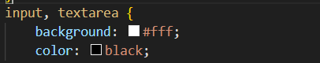border-radius: 5px; → Rounds the corners of the elements slightly, making them look more modern and visually appealing.

The snippet specifically styles the and <input> elements by setting their text color to black and their background color to white (#fff). When users enter text, this guarantees a clear and readable interface. Furthermore, by using these styles, the form elements enhance the user experience by creating a pleasing contrast with the page's gradient background. <br> <br>• This styling is a component of your HTML file's larger CSS, which includes various user interface elements created for a user-friendly and aesthetically pleasing translation interface. In addition, the CSS contains styles for output sections, buttons, and a.container class that organizes and centers the layout. These styles improve readability and accessibility, making it simple for users to engage with the translator by choosing a language, entering text, and seeing the translator by entering text, selecting a language, and viewing the translated output efficiently.

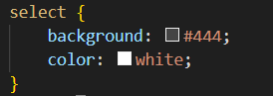

A CSS rule that styles the element in your AI-Powered Multilingual Translator project is displayed in the attached image. A sleek and contemporary appearance is achieved by setting the background property to #444, a dark gray color. This improves the overall design by guaranteeing that the dropdown menu complements the dark-themed user interface. With the color property set to white, the dropdown's text will always be readable against the dark background.   
By keeping the contrast between the text and its background high, this styling decision enhances readability and user experience, especially in low-light conditions. Additionally, the element's darker background complements the translator interface's overall theme, guaranteeing uniformity among all interactive elements like buttons input fields.

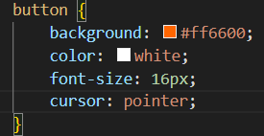

The element in your AI-Powered Multilingual Translator project is styled by the CSS rule shown in the attached image. The button's background property is set to #ff6600, a vivid orange hue that draws the eye and promotes user interaction. Because the color property is set to white, the button's text will stand out against the bright background and be readable. Furthermore, the font-size is set to 16px, which ensures that the text is readable without overpowering the user interface.   
Because it transforms the cursor into a pointer (hand icon) when the user hovers over the button, the cursor: pointer; property is essential for improving the user experience. This enhances usability by giving a clear visual indication that the button can be clicked. When combined, these styles produce a striking and

eye-catching and user-friendly button design, ensuring that key actions such as translation, file uploads, or text copying are easily accessible and intuitive for users.

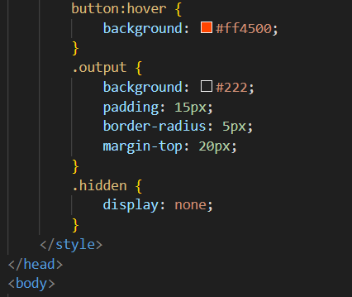

Three essential components of your AI-Powered Multilingual Translator project are styled by the CSS code above. The button:hover rule improves the visual feedback and makes interactions more intuitive by changing the button's background color to #ff4500, a darker shade of orange, when the user hovers over it. The user experience is enhanced by this hover effect, which makes it clearer to users that the button is interactive.   
The translated text display section is styled by the.output class. It is set apart from other elements by a 20px top margin, a 5px border-radius for rounded corners, a 15px padding for spacing, and a dark gray background (#222). This guarantees that the translated text is presented in a recognizable, organized space. Last but not least, the.hidden class sets display: none;, indicating that elements assigned this class (like as the translation output section before results are available) are initially hidden. Once translation is performed, JavaScript removes this class to display the results dynamically. This styling improves both aesthetics and functionality by maintaining a clean and organized interface.

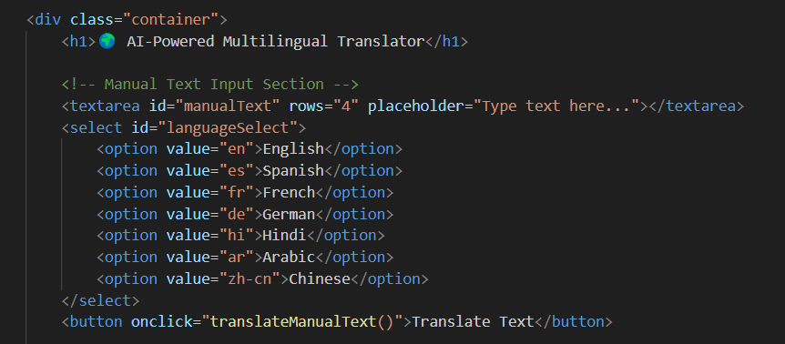

A portion of the AI-Powered Multilingual Translator interface is defined by the supplied HTML code, which enables users to enter text and choose a language for translation. It is contained in a

with the class "container" that acts as a structured container for the content. The emoji 🌍 and title in the heading (

**) add interest and ease of use to the interface. Users can enter text for translation in the manual text input section, which is defined beneath the heading and consists of a element with the id="manualText" property. The "Type text here..." placeholder tells the user what to enter.**

Furthermore, a dropdown (id="languageSelect") allows users to select the target translation language by offering a variety of language options, including English, Spanish, French, German, Hindi, Arabic, and Chinese. The language code is represented by a value attribute for each element (for example, "en" for English and "es" for Spanish). Lastly, a onclick="translateManualText()" event is added to a element. This means that when the button is clicked, the JavaScript function translateManualText() will be called to process the translation. This part of the code efficiently gives users an organized and interactive method to enter text and choose a translation language.

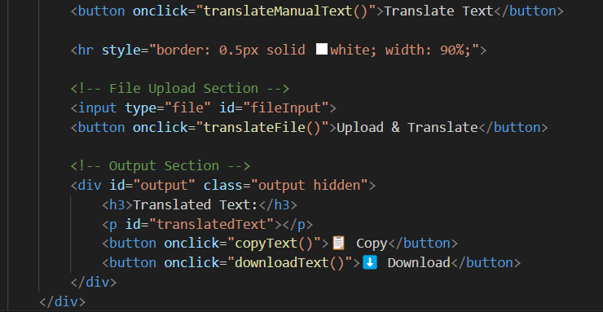

Key functional areas of the AI-Powered Multilingual Translator are defined by the provided HTML code, which enables users to manually enter text, upload a file for translation, and view the translated output. The button () in the first section has a onclick event that calls translateManualText(), which, when clicked, starts the translation process. The interface's various sections are visually separated by a horizontal rule (<hr>)

The element (type="file") in the File Upload Section allows users to upload documents, and a button (onclick="translateFile()") allows users to start translating the uploaded file. Because the Output Section is organized inside a

with id="output" and class="output hidden," it stays hidden until the translation results are available. A

element with id="translatedText" dynamically contains the translated content, while a

**heading inside this section shows "Translated Text:". Two buttons also facilitate interaction: one calls downloadText() to enable users to download the translated output, while the other calls copyText() to copy the translated text to the clipboard. An interactive and user-friendly translation experience is guaranteed by this methodical approach.**

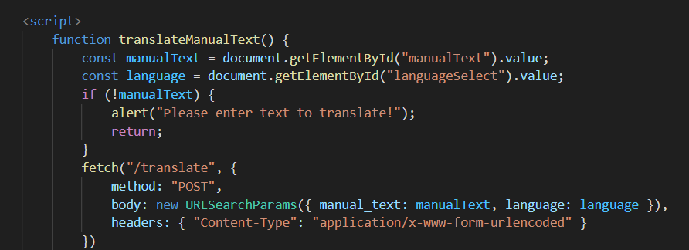

The AI-Powered Multilingual Translator's manual text translation feature is managed by the supplied JavaScript function translateManualText(). It first retrieves the language that was chosen from the dropdown with id="languageSelect" and the user-inputted text from the element with id="manualText." An alert message stating, "Please enter text to translate!" is displayed if the user tries to translate without providing text, and the function ends with return. The function uses the fetch API to send a POST request to the /translate endpoint if valid input is supplied. In order to encode the input text and chosen language in a format appropriate for form submission, the request body is built using URLSearchParams. In order to ensure correct encoding, the request additionally contains a Content-Type header that specifies "application/x-www-form-urlencoded." The translated text should be returned by the server after processing so that it can be shown on the webpage. Through dynamically managing user input and interacting with the backend translation service, this function guarantees an effective and engaging translation experience.

The function uses the fetch API to send a POST request to the /translate endpoint if valid input is supplied. In order to encode the input text and chosen language in a format appropriate for form submission, the request body is built using URLSearchParams. In order to ensure correct encoding, the request additionally contains a Content-Type header that specifies "application/x-www-form-urlencoded." The translated text should be returned by the server after processing so that it can be shown on the webpage. Through dynamically managing user input and interacting with the backend translation service, this function guarantees an effective and engaging translation experience.

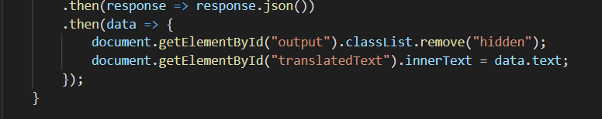

This JavaScript snippet is part of the function handling the translation process. It processes the server's response after making a translation request. The .then(response => response.json()) line converts the fetched response into a JSON object, allowing the script to extract and manipulate the returned data. The next .then(data => { ... }) block ensures that the translated text is displayed on the webpage.

Within this block, document.getElementById("output").classList.remove("hidden"); makes the **output section visible** by removing the "hidden" CSS class, which was initially applied to keep the section hidden until content is available. Then, document.getElementById("translatedText").innerText = data.text; updates the <p> element with id="translatedText" to display the translated text received from the server. This ensures a smooth user experience by dynamically showing and updating the 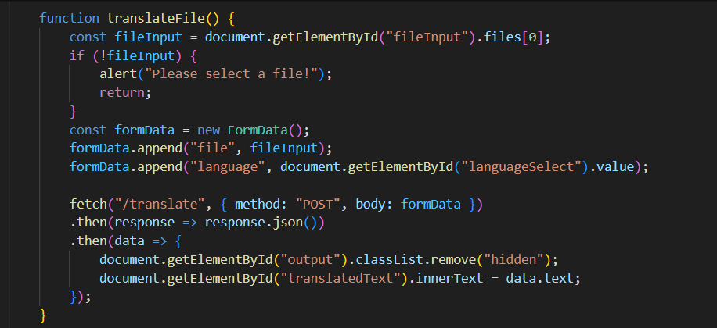translation output.

File uploads for translation are handled by the translateFile() JavaScript function. First, it uses id="fileInput" to retrieve the chosen file from the input element. The function ends if no file is selected and an alert asks the user to select one. The chosen language (retrieved from id="languageSelect") and the chosen file are then sent as a POST request to the /translate endpoint after being added to a FormData object.

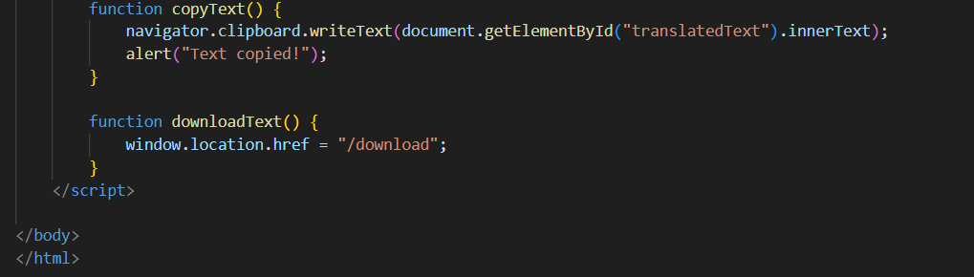Once the request is sent, the function waits for a response, converts it into JSON, and updates the UI accordingly. When the server responds with translated text, the hidden output section (id="output") is made visible by removing the "hidden" class. The translated text is then displayed inside the paragraph element with id="translatedText". This ensures that users see the translation result dynamically after their file is processed.

This JavaScript code defines two functions, copyText() and downloadText(), which enhance user interaction by providing options to copy translated text to the clipboard and download it.

The copyText() function retrieves the text content from the HTML element with id="translatedText" and uses the navigator.clipboard.writeText() method to copy it to the clipboard. Once the text is successfully copied, an alert notifies the user with the message "Text copied!". The downloadText() function, on the other hand, redirects the user to the /download endpoint by changing window.location.href, which likely triggers the download of the translated text.

***JavaScript***

The main purpose of JavaScript, a high-level, interpreted programming language, is to create interactive web pages. Because it is a client-side scripting language, it operates within the user's browser and makes possible features like form validation, event handling, animations, and API interactions. Along with HTML and CSS, JavaScript is a fundamental technology in web development.   
Our AI-Powered Multilingual Translator project relies heavily on JavaScript because it allows for dynamic content updates and interactivity without requiring a page reload. JavaScript is specifically used to:

✅ Manage User Inputs – It records file uploads, text input, and specific languages for translation.   
  
✅ Send Requests to the Backend: JavaScript can send files or text to the Flask/Python backend for processing by using the fetch() API.   
✅ Instantaneous Translation Text Update: After the translation is received from the backend, JavaScript updates the webpage dynamically to display the translated output.  
✅ Enhance User Experience – It ensures a smooth and interactive experience by handling button clicks, form submissions, and displaying results without page refresh.

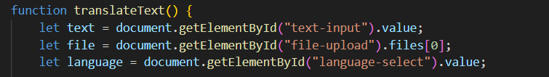

The values entered by a user in an HTML form are retrieved by this JavaScript function, translateText(). Three essential components are received: language, file, and text. The value from an input field with id="text-input"—likely a text box where users enter text to be translated—is stored in the text variable. Users can upload a file for translation by using the file variable, which retrieves the first uploaded file from an input field with id="file-upload." Lastly, the language variable specifies the preferred translation language by selecting the language from a dropdown menu with id="language-select."

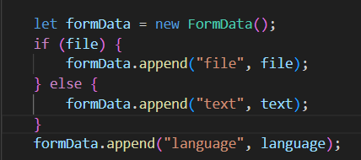This function prepares the necessary data for further processing, such as sending it to a server for translation. However, it does not yet perform any actions like sending a request or displaying results. To make it functional, additional logic (e.g., validation, API calls, and response handling) would be needed.

In response to user input, this JavaScript code snippet generates a FormData object for dynamic data storage. When managing file uploads, the formData object is especially helpful in getting data ready for submission via an HTTP request. The code first determines whether the user has supplied a file. The file is appended to formData with the key "file" if a file is selected. In the event that no file is chosen, the key "text" is appended to the text input (text).

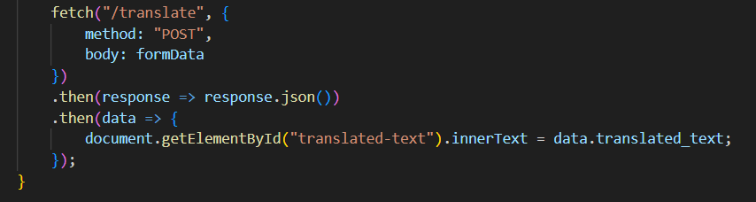Additionally, the selected language is appended to formData under the key "language". This structure ensures that either a file or text input is sent along with the selected language, allowing flexibility in how data is submitted. This approach is commonly used when implementing file upload and text-based translation features in web applications.

This JavaScript code sample uses the fetch API to send a POST request with the formData object as the request body to the "/translate" endpoint. The formData includes the chosen language, which is translated by the server, and either a text input or a file. The fetch function starts the request and watches for the server to respond.   
The response is processed and transformed into a JavaScript object by the.then(response => response.json()) function after it has been received. The translated text is taken from the server response (data.translated_text) and shown in an HTML element with the ID "translated-text" in the following.then(data => {... }) block. By ensuring that the translated output is updated dynamically on the webpage, this implementation gives the user real-time feedback.

After applyning codes in vs code.. Open terminal and type-

Python app.py

Click on the <http://127.0.0.1:5000> to run our AI-MULTILINGUAL INTERFACE

AI-MULTILINGUAL INTERFACE Looks like this:

So here we are testing our AI-MULTILINGUAL TRANSLATOR

EXAMPLE 1:

Type anything in the text columns like this:

Then we select the language, like hindi-

Output:

After translating the text you could download it for the future references-

Example 2: Covert French docx into English language

So first we choose our docx-

And search for French Docx which we want to translate in English-

The docx looks like this

Open that file and press upload & translate button to translate it in English

As you see above, the french docx is trenslated in english successfully, or you can easily download it for your future reference.

Example 3: We translate a English poem (Picture) into German language.

The procedure will be same, just choose a file or picture which you want to translate.

Here we are extracting the words which is in the poem like this

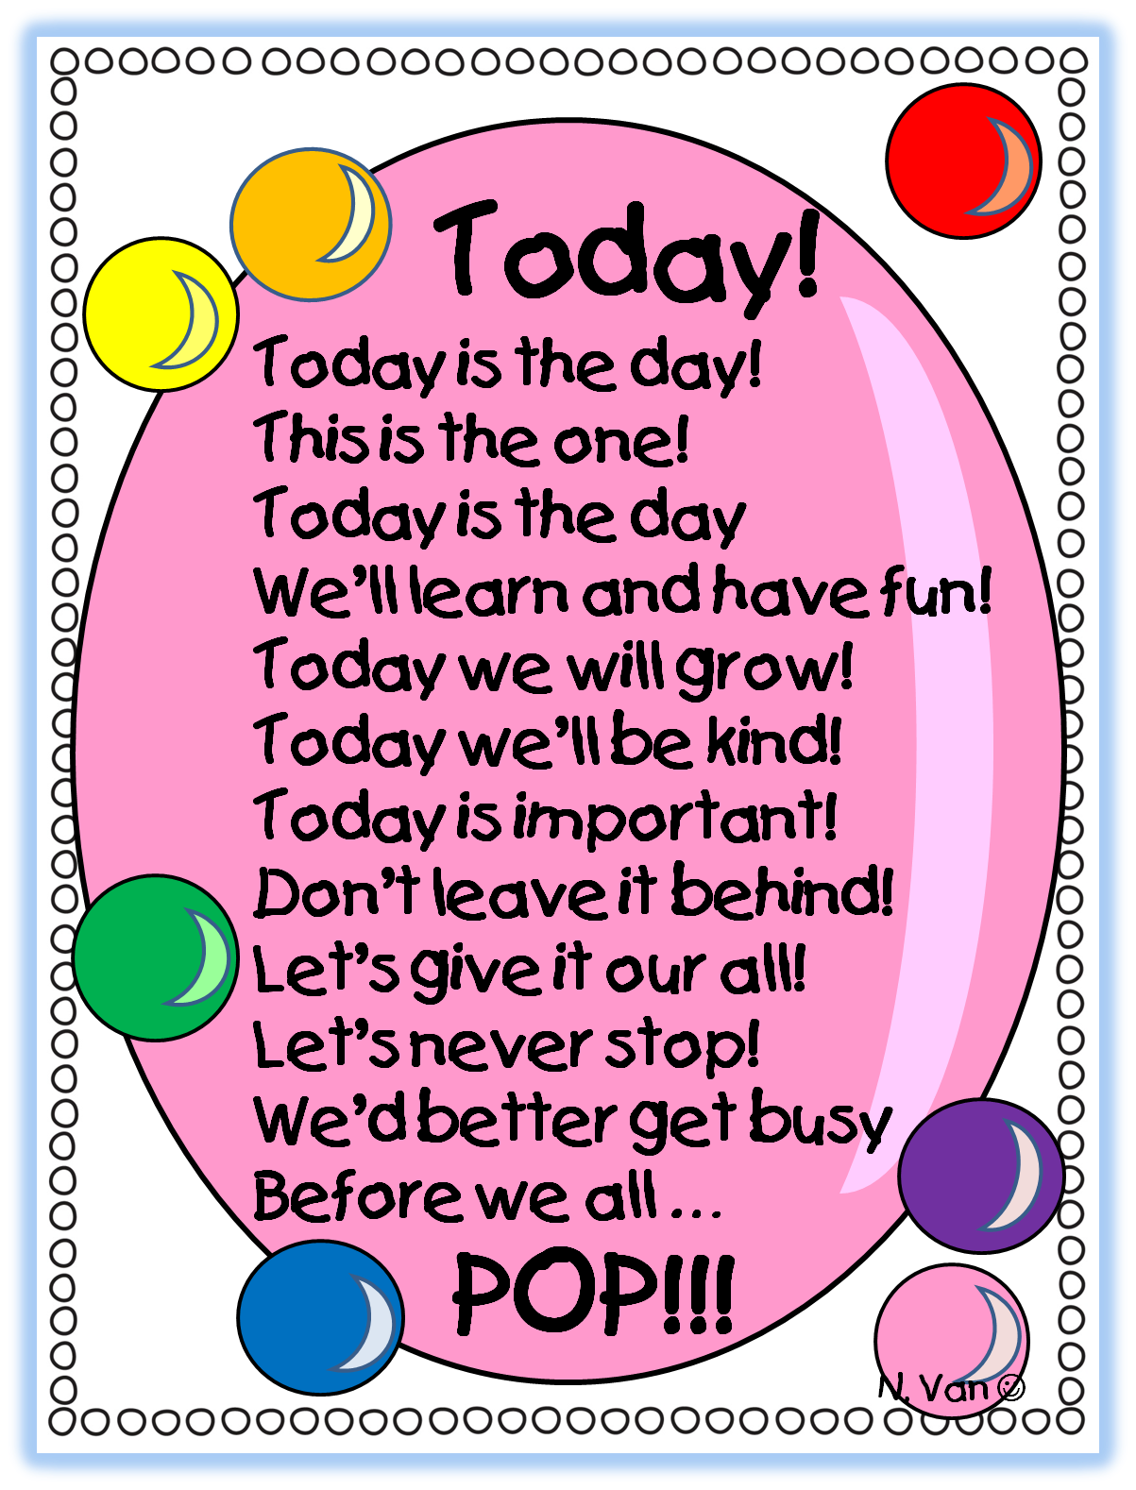

We’re going to translate it in German Language-

First just choose an file-

Click upload & translate-

Here you see the input is successfully translate in german language. You’ll also download it for your future references.

Every translation you’ll downloaded will display in your download section of your pc like this-

***DOWNLOADS***

How my computer downloads my translations:   
In addition to translating text in real time, the AI Multilingual Translator lets users save the translated text as a file for later use. Users who need to store translated content for offline access, reference, or documentation will find this feature helpful.  
A combination of the following has been used to implement the download functionality:   
  
The translated file will be served by Flask (Backend Processing).   
✅ JavaScript (Frontend Interaction): to initiate the download.   
✅ HTML (User Interface): to include a download button.   
The procedure, implementation, and operation of the download feature are described in this section.   
1. How the Download Function Operates   
The output of a user's translation is saved on the server as a file. After that, the system displays a Download button.

**Step-by-step Process:**  
1️. The user enters text, selects a language, and clicks the **Translate** button.  
2️.The Flask backend processes the input and generates a translated output.  
3️.The translated text is saved in a file (translated.txt) in the uploads/ directory.  
4️.The **Download** button appears, allowing the user to retrieve the file.  
5️.When the **Download** button is clicked, a request is sent to the Flask /download route.  
6️.Flask **sends the translated file** back to the user as a downloadable attachment.  
7️.The file is saved in the **Downloads folder** of the user’s device.

**Functions Used to Enable the Download Feature**

The download feature is implemented using **Flask (Backend)** and **JavaScript (Frontend).** Here’s a breakdown of the key functions:

**A. Flask Route for Handling File Download**

In the **Flask application (app.py)**, a route is created to handle file downloads:

**Explanation of the Code:**

🔹 send_file(): This Flask function sends the requested file from the server to the user’s browser.  
🔹 os.path.join(UPLOAD_FOLDER, "translated.txt"): This points to the file path where the translated text is stored.  
🔹 as_attachment=True: Ensures that the file is **downloaded** instead of being opened in the browser.

**What Happens in This Route?**

✔️ When the user clicks **Download**, their browser sends a request to the /download route.  
✔️ Flask locates the translated.txt file in the uploads/ folder.  
✔️ Flask sends the file to the user’s device as an attachment.  
✔️ The file gets saved in the **Downloads** folder of the user's computer.

**B. JavaScript Function for Downloading the Translated File**

The **frontend (HTML + JavaScript)** interacts with Flask to initiate the file download.

**Explanation of the Code:**

✅ window.location.href = "/download";

* This line **redirects the browser** to the Flask /download route.
* Since Flask is set up to serve translated.txt, the file download starts automatically.

**How This Works in Action?**

1️.The user **clicks the Download button** on the webpage.  
2️.The downloadText() function runs, triggering a request to the Flask /download route.  
3️.The browser receives a file from the Flask backend.  
4️.The file download **automatically starts** on the user’s device.  
5️.The translated text file appears in the **Downloads** folder.

**C. HTML Button to Trigger Download**

The **HTML button** is placed in the webpage UI so the user can download their translated text easily.

**How This Button Works:**

🔹 The onclick="downloadText()" calls the JavaScript function when clicked.  
🔹 The JavaScript function redirects the browser to /download, triggering the file download.  
🔹 The translated text file is **saved** on the user’s computer.

* 1. **Where the Downloaded File Appears**

After clicking **Download**, the translated text file (translated.txt) appears in the user's **Downloads** folder.

**File Format:**

The file will be saved as **translated.txt**, which can be opened with any text editor such as:  
📌 **Notepad** (Windows)  
📌 **TextEdit** (Mac)  
📌 **VS Code, Sublime Text, or any IDE**

* 1. **Example Use Cases for the Download Feature**

🔸 **Students & Researchers**: Save translated documents for future reference.  
🔸 **Business Professionals**: Store translated contracts or official documents.  
🔸 **Writers & Translators**: Keep translated versions of books or articles.  
🔸 **Language Learners**: Download translated phrases for learning practice.

***CONCLUSION***

The AI-Powered Multilingual Translator is a cutting-edge tool that uses NLP-based translation, OCR technology, and artificial intelligence to overcome language barriers. This project is very flexible and easy to use, enabling users to translate text from both scanned documents and manual input. The system's multilingual support guarantees easy communication and accessibility for professionals, students, and tourists from all over the world. The accuracy and efficiency of the translations are improved by integrating Python (Flask) for backend processing and JavaScript for dynamic interactions.

This project's user-friendly interface and practical features, such as the capacity to download, save, and copy translated text, are among its main advantages. While OCR technology enables text extraction from images and scanned documents, the Google Translate API guarantees precise and context-aware translations. For users working with printed text, handwritten notes, or documents in foreign languages, these features make the translator an invaluable tool. The project shows how AI-powered solutions can enhance multilingual information access and streamline communication.   
In the future, this system could be greatly improved with features like offline functionality, real-time speech translation, and AI-driven contextual learning to improve translation accuracy. The incorporation of customized language models and increased linguistic support will get better as technology develops.

***LIMITATIONS***

1.Reliance on Internet Connection: A steady internet connection is necessary for the translation process, which depends on external APIs like Google Translate. Offline functionality is an essential future enhancement because users in places with inadequate connectivity may have trouble accessing the translation services.  
  
  
2. Limited Accuracy for Complex Sentences: Although AI-based translation systems are effective, they might have trouble understanding idioms, slang, and phrases that are sensitive to context. Particularly for languages with intricate grammatical structures, the translations may not always be contextually correct or grammatically flawless.   
  
3. OCR Errors in Text Extraction Text is extracted from documents and images using optical character recognition (OCR) technology. It might, however, translate text incorrectly if it misinterprets characters, particularly in handwritten or hazy text. Advanced AI models can be used to improve this for **AI models** for better accuracy.

4.Limited Language Support: Despite the project's multilingual capabilities, it is still only compatible with the languages listed in the Google Translate API. Certain users may find it less accessible if certain regional or uncommon languages are not fully supported.

5. Privacy and Security Issues • Privacy and data security may be an issue because user-provided text or documents are transmitted to external APIs for translation. If not handled securely, sensitive information shared in documents could be in danger. Local AI models for improved privacy may be part of future developments.

6. No Real-Time Speech Translation • Real-time speech translation is not supported by the current system, which concentrates on text-based translation. Speech synthesis and voice input would enhance usability and enable more natural cross-linguistic communication.

***FUTURE SCOPE***

1) Improved Translation Precision through AI and Machine Learning : To improve translation accuracy, future developments will incorporate cutting-edge AI models like GPT-based neural networks. Translations will be more accurate and natural thanks to these models' comprehension of tone, context, and cultural quirks.  
  
2) Offline Translation Capabilities: At the moment, the system uses web-based APIs. In the future, offline AI-powered translation models may be added, enabling users to translate text even when there isn't a live internet connection. Travelers and users in remote locations will benefit from this.   
  
3) Real-Time Speech Translation Adding text-to-speech and speech-to-text features will allow for multilingual communication in real time. This feature will instantly break down language barriers and be helpful for live conversations, business meetings, and educational purposes.

4) Increased Language Support: Additional regional and indigenous languages that aren't currently supported by major translation APIs could be added to the project's support list. This can support the accessibility and preservation of lesser-known languages around the world.  
  
  
5) Integration with Smart Devices & Assistants The translator can be integrated with smart devices and virtual assistants (such as Alexa, Siri, and Google Assistant) to enable hands-free and smooth language translation, making interlanguage communication simple in day-to-day interactions.   
  
6) Better Optical Character Recognition (OCR) for Document & Image Translation: Upcoming iterations can improve OCR to better extract text from handwritten documents, scanned PDFs, and low-quality images. This will improve the accuracy and dependability of document translation.

7) Privacy-Focused AI Translation Models: The project can use on-device AI models to process translations locally rather than depending on cloud-based services. Users will be able to translate private or sensitive documents without worrying about privacy issues thanks to improved data security.

***REFERENCES***

1. Tesseract OCR: This open-source OCR engine is used to extract text from scanned documents and photos.   
o Website: https://github.com/tesseract-ocr/tesseract  
  
2. EasyOCR: A multilingual OCR library based on deep learning.   
o Reference: https://www.jaided.ai/easyocr/   
  
3. Poppler: A rendering library for PDFs that allows text extraction.   
o Poppler.Freedesktop.org is the official repository.   
  
4.pdf2image: This Python package turns PDFs into images for OCR processing.   
o PyPI: https://pypi.org/project/pdf2image/   
  
5. Google Translate API: A cloud-based multilingual translation API.   
o Documentation: https://cloud.google.com/translate/docs   
  
6. Flask Framework: This Python web framework is used to construct the backend of applications.   
o Reference: https://flask.palletsprojects.com/   
  
7. JavaScript Fetch API: This API is used to send and receive translation data via HTTP requests.   
o MDN Web Documents: https://developer.mozilla.org/en-US/docs/Web/API/Fetch_API